Papers written by
Australian Maths Software

SEMESTER ONE
YEAR 12
MATHEMATICS METHODS
REVISION 1
Unit 3

2016

Section One
(Calculator–free)

Name: _________________________________

Teacher: _______________________________

TIME ALLOWED FOR THIS SECTION

Reading time before commencing work: 5 minutes
Working time for section: 50 minutes

MATERIAL REQUIRED / RECOMMENDED FOR THIS SECTION

To be provided by the candidate
Standard items: pens, pencils, pencil sharpener, highlighter, eraser, ruler.

IMPORTANT NOTE TO CANDIDATES

No other items may be taken into the examination room. It is your responsibility to ensure that you do not have any unauthorised notes or other items of a non–personal nature in the examination room. If you have any unauthorised material with you, hand it to the supervisor before reading any further.

To be provided by the supervisor

Question/answer booklet for Section One.
A formula sheet which may also be used for Section Two.
Structure of this examination

 | Number of questions available | Number of questions to be answered | Working time (minutes) | Marks available | Percentage of exam
Section One  Calculator—free | 7 | 7 | 50 | 50 | 35
Section Two  Calculator—assumed | 13 | 13 | 100 | 100 | 65
Total marks |  |  |  | 150 | 100

Instructions to candidates

1. The rules for the conduct of this examination are detailed in the Information Handbook.
Sitting this examination implies that you agree to abide by these rules.

2. Write your answers in the Question/Answer booklet.

3. You must be careful to confine your responses to the specific questions asked and to
follow any instructions that are specific to a particular question.

4. Spare pages are provided at the end of this booklet. If you need to use them, indicate
in the original answer space where the answer is continued i.e. give the page number.

5. Show all your working clearly. Your working should be in sufficient detail to allow your
answers to be checked readily and for marks to be awarded for reasoning. Incorrect
answers given without supporting reasoning cannot be allocated any marks. For any
question or part question worth more than two marks, valid working or justification is
required to receive full marks. If you repeat an answer to any question, ensure that you
cancel the answer you do not wish to have marked.

6. It is recommended that you do not use pencil, except in diagrams.

7. The Formula Sheet is not to be handed in with your Question/Answer booklet.

1. (7 marks)
Find  for each of the following
(a) 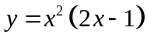. (2)

(b) 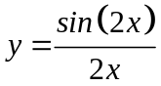. (3)

(c) 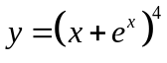. (2)

2. (9 marks)
(a) The acceleration function of a particle is graphed below Use it to graph the
velocity and displacement graphs. (4)
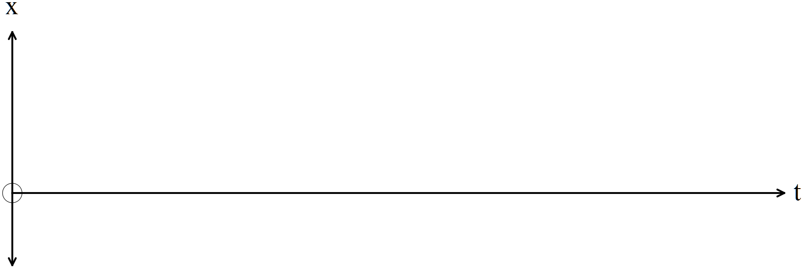
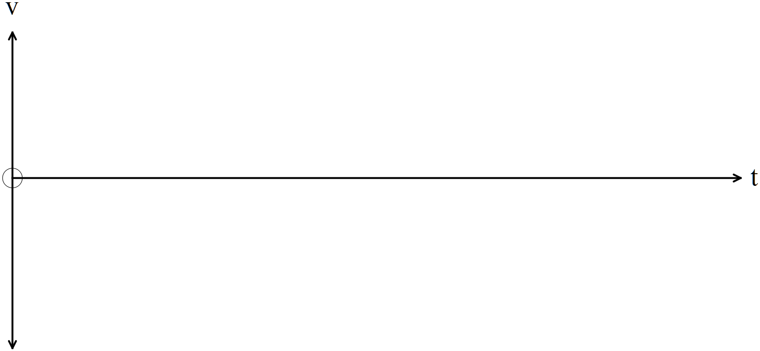
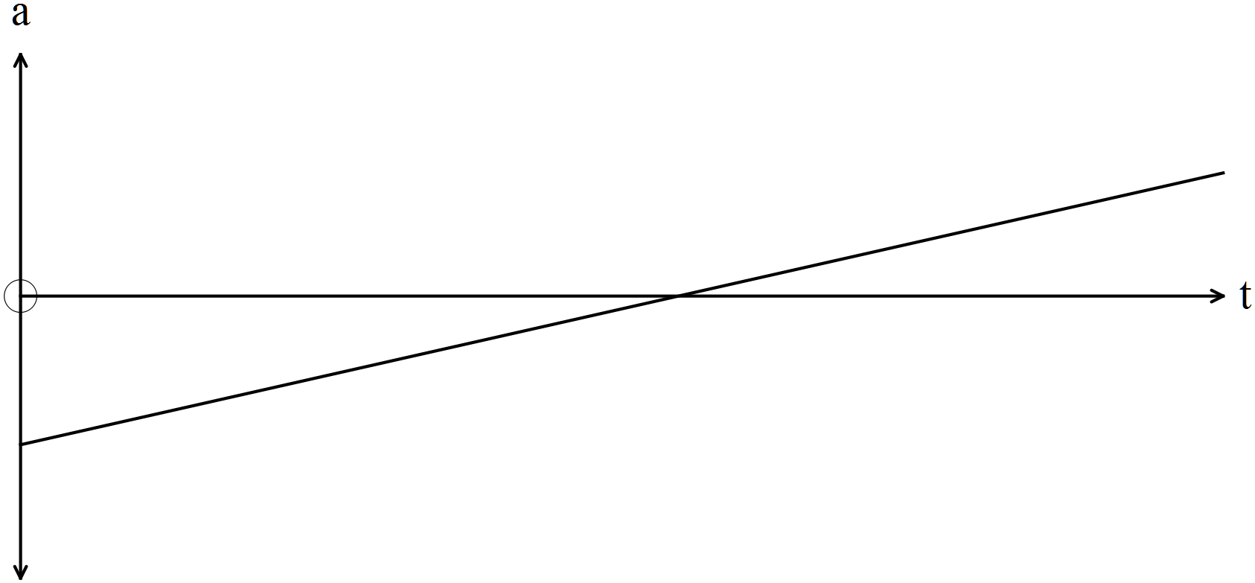
(b) What type of function does is the displacement graph represent? (1)

(c) Explain how 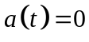 on the acceleration graph relates to the displacement
graph. (1)

(d) Explain how on the acceleration graph relates to the velocity graph. (1)

(e) Explain how 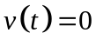 on the velocity graph relates to the displacement
graph. (2)

3. (6 marks)
(a) Find the following
(i) 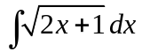 (2)

(ii) 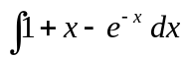 (2)

(b) Given 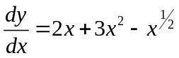 find the function  given the point 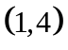 belongs to the function. (2)

4. (7 marks)
Evaluate the following
(a) 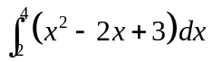 (3)

(b) 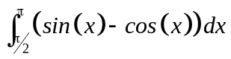 (2)

(c) 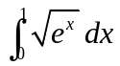 (2)

5. (5 marks)
Consider the graph of 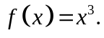
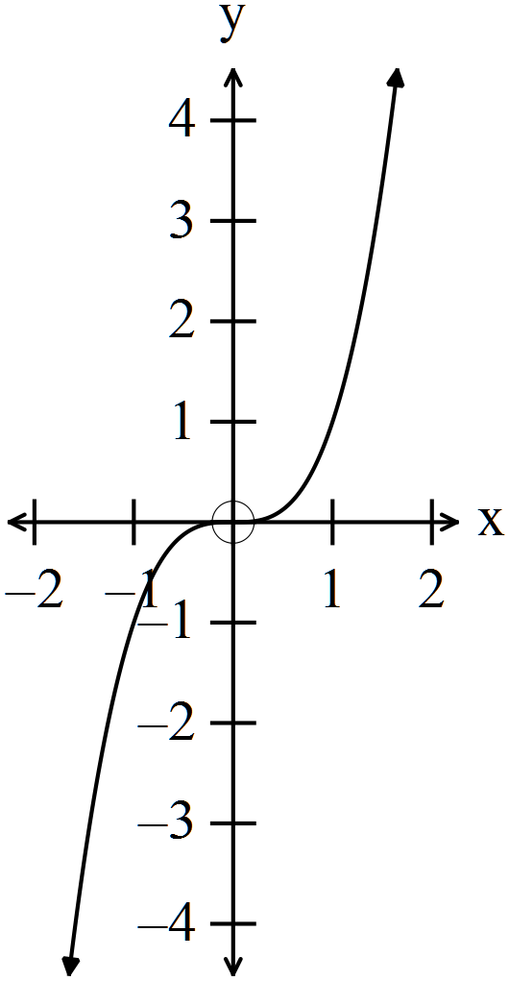

(a) Complete the following.
(i) 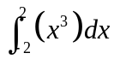 (1)

(ii) 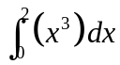 (1)

(iii) Evaluate the area between the function, the x axis and the bounds
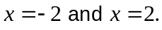 (1)

(b) True or false? Give your reasons.
(i) 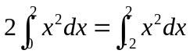 (1)

(ii) 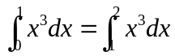 (1)
6. (8 marks)
(a) If 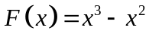
(i) find 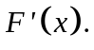 (1)

(ii) hence sImplify 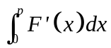 (2)

(b) Given 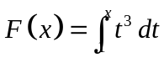 find an expression for (2)

(c) Find 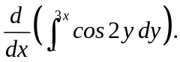 (3)

7. (8 marks)
Given
(a) (i) find 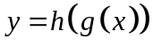. (1)

(ii) show 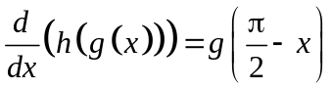 (2)

(b) (i) find 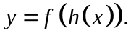 (1)

(ii) hence find the expression for 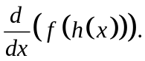 (2)

(c) find 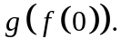 (2)

END OF SECTION ONE

